

NOTICE OF COMPLETE APPLICATION AND PUBLIC MEETING
TO INFORM THE PUBLIC OF A ZONING BY-LAW AMENDMENT

TAKE NOTICE that the Council for The Corporation of the Municipality of Powassan has received a complete application under Section 34 of the Planning Act, R.S.O. 1990, c.P. 13 as amended, to inform the public of a proposed Zoning By-law Amendment.

The public meeting is being held for the application described below to enable interested members of the public to understand and comment on the proposed Zoning By-law Amendment application.

DATE AND LOCATION OF PUBLIC MEETING

File #: 2026-01
Date: Wed., March 25, 2026 (Rescheduled from March 3, 2026
Time: 6:00 pm
Location: Municipality of Powassan – 252 Clark Street (Fire hall)

PURPOSE AND EFFECT OF THE ZONING BY-LAW AMENDMENT

The purpose and effect of the proposed Zoning By-Law Amendment is to amend the Restricted Area Zoning (By-Law No. 2003-38), as amended, for the lands described as Plan 57, Block 7, PT Lot 25; PT LT 16 CON 12 HIMSWORTH, POWASSAN, (Civic Address: 81 King Street), in the Municipality of Powassan to allow a future commercial use.

The application, if approved, would rezone the subject land from Village Residential (RV1) Zone to Village Commercial (CV1) Zone.

ADDITIONAL INFORMATION

A key map showing the land to which the proposed amendment applies is provided with this notice. Any person who participates in the meeting can speak to the application with questions, concerns or support.

No one other than the applicant, the municipality, certain public bodies and the Minister may file an appeal of the decision.

If you wish to be notified of the decision of the Council for the Corporation of the Municipality of Powassan in respect to the proposed Zoning By-law Amendment, you must submit a written request (with forwarding addresses) to the Clerk of the Municipality of Powassan at 250 Clark Street, Powassan, Ontario, P0H 1Z0.

Additional information regarding the proposed amendment is available to the public for inspection at the Municipality of Powassan Municipal Office located at 250 Clark Street on Monday to Friday, between the hours of 8:30 a.m. and 4:30 p.m. please call (705) 724-2813.

Mailing Date of this Notice: March 5, 2026

Kimberly Bester, Deputy-Clerk
Municipality of Powassan
kbester@powassan.net

Location Map

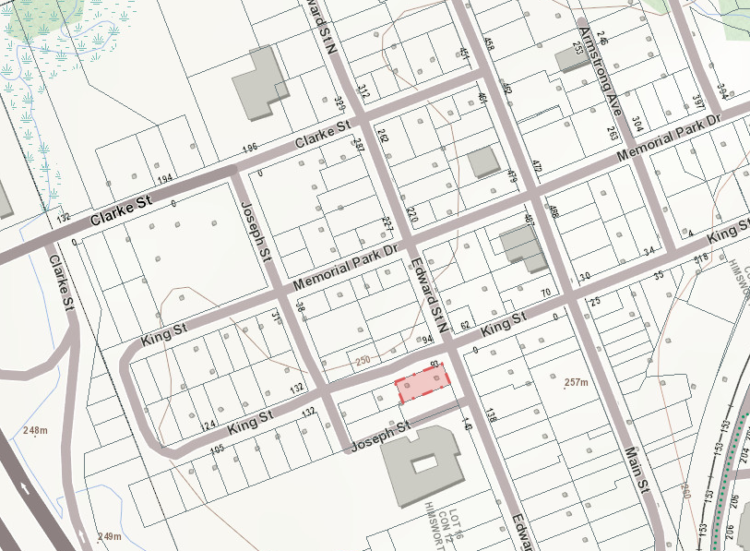
Subject Property

N

